**Capital Budgeting Decision**

**National Fertilizers Limited (NFL)**

**Submitted By**

**Name: J Beniesuja (F19079)**

**Date: 02/02/2020**

**1. Year –Month of Capital budgeting decision along with place of implementation**

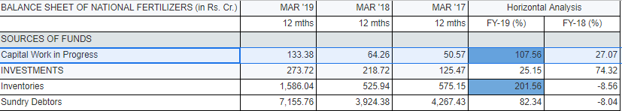

**FIG 1.1**

As of march 31st 2019,There is no major capital budgeting decision taken. But as of Capital Work-in-Progress : The Company is in the process of executing various energy reduction projects in all units of the Company. This is a major capitalization against which major debt has been taken from Bank(s).

**2.Nature of Capital budgeting decision: cost cutting or profit expansion**

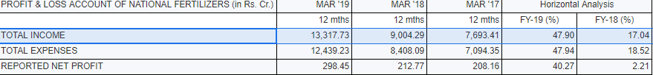

**FIG 1.2**

From the above figure it is evident that both the expense and profit are in an increasing pattern.The energy reduction process during the initial stage will cost more and hence as of now it looks as profit expansion process. But in the long run , the investment will decrease and the profit will increase due to the reduction of use of energy and then it will be a cost cutting decision.

**3. How much is the estimated investment outlay**

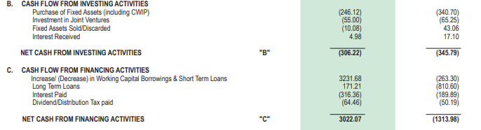

**FIG 1.3**

It is very clear from the fig 1.3 that there is no investing activity but on the other hand there is a major financing activity in terms of working capital borrowings and short term loans.

**4. Duration of Capital Budgeting Implementation**

Since it is the process of reduction of energy usage in all the existing units and there is no major capital budgeting decision other than this, the duration of capital budgeting can’t be determined.

**5. Mode of Financing to meet the cost of investment outlay**



**FIG 1.4**

The mode of financing to meet the working capital is found to be through **secured loans**.

Long Term Loans : To meet the funding requirement for energy saving and capex schemes, Company has entered into a Rupee Term Loan Agreement with SBI on 24.12.2018 for `1044 crore. Long term borrowings as on 31.03.2019 were `341.49 crore which included outstanding against Rupee Term Loan of `218.40 crore and external commercial borrowings (ECBs) of `123.09 crore.

Short Term Loans :Short Term borrowings of `6122.11 crore (previous year `2890.43 crore) as on 31st March, 2019 were outstanding

**6. Impact of Capital budgeting on Operations ,Marketing channels and HR practices of individual companies**

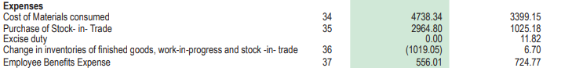

**FIG 1.5**

In general the impact on operations is that it incurred more cost and in case of HR practices it is reduced which is possible due to the reduction in the number of employees working.

In case of marketing channel, since it is a government company not much is invested in marketing and is considered to be trivial.

**7. Impact on Operating Revenue ,EBIT,PAT,EPS,MPS,Market capitalization, Enterprise value – To study the rate of increase or decrease i-e rate of change, the cut off 31 Mar,Year.**

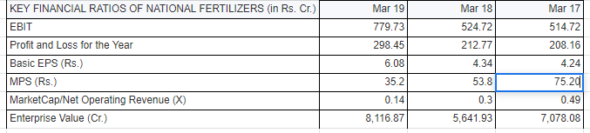

**References:**

* [**https://www.moneycontrol.com/financials/nationalfertilizers/ratiosVI/NF06?classic=true**](https://www.moneycontrol.com/financials/nationalfertilizers/ratiosVI/NF06?classic=true)
* [**https://nationalfertilizers.com/images/pdf/investorsdesk/NFLAnnual_Report_45.pdf**](https://nationalfertilizers.com/images/pdf/investorsdesk/NFLAnnual_Report_45.pdf)
* [**https://nationalfertilizers.com/images/pdf/investorsdesk/Financial_statements_2017-18.pdf**](https://nationalfertilizers.com/images/pdf/investorsdesk/Financial_statements_2017-18.pdf)
* [**https://www.moneycontrol.com/financials/nationalfertilizers/balance-sheet/nf06**](https://www.moneycontrol.com/financials/nationalfertilizers/balance-sheet/nf06)
* [**https://economictimes.indiatimes.com/national-fertilizers-ltd/profitandlose/companyid-11632.cms**](https://economictimes.indiatimes.com/national-fertilizers-ltd/profitandlose/companyid-11632.cms)